How to adjust perfectly the sweep angle

A factor that can affect the safety in very gusty and turbulent conditions is a to high or to low bar pressure setting. The Ghostbuster let its bar pressure vary with the nose angle (sweep). There is a setting that is the best where the bar pressure presents the following behaviour with flaps at 0° (Exxtacy) retracted (Ghostbuster):

1. 60 km/h = 38 mph small/medium
2. 80 km/h = 50 mph medium (Please note, the maximum certified speed according DHV certification is 80km/h)
3. 100 km/h = 63 mph medium/strong

There is a measuring procedure attached, but there is a very simple flight test to be sure that your glider is in the right setting. If the glider let it self fly easily over 90 km/h with positive bar pressure all the way, there is nothing to change.

If you move the screw in the nose fitting a half turn inside (shortening), the tips of the glider goes backwards increasing the sweep and decreasing the nose angle. The result is an increase in the bar pressure. In smooth to moderate turbulent air there is a range of bar pressure that allow different pilots fly pleasantly the Ghostbuster but as soon as the conditions get gusty some settings come be unpleasant or dangerous. Any glider that has a to low bar pressure has usually a negative bar pressure at high speeds making the gust feedback critical. By the other hand if the Ghostbuster has a to high bar pressure it can present an uncomfortable high build up of bar pressure in gusty weather. This feature takes all the pilot sensitivity away making co-ordinate curves difficult. If this is the case, the correction is very simple: the pilot has only to increase the nose angle shortening the turnbuckle half a turn. It has to be noticed that changing the nose angle also present some side effects.

to much bar pressure | to little bar pressure
- glider is neutral in curves without high siding  - trim speed increases  - higher roll rates  - difficult to land | - glider tries to slip in the curve needs high siding  - trim speed decreases  - lower roll rates

If a glider does not let it self adjust in a position with the correct bar pressure and no side effects, then the glider sweep should be adjusted so that the bar pressure is in the lower then desirable and a ring should de added on each of the last rib increasing the twist.

Very important to remember is that the sail belts at the keel should always be stiff. The difference in sweep between a loose belt and a stiff is equivalent of a 1/4 of turn in the turnbuckle in the direction of increasing sweep (tips moving backwards). It should also be remembered that loose belts also produce bad flight behaviours and speed bumps. In general if you increases the sweep you have to readjust the belts, and in many cases if you decreases the sweep you don't need to release the tension in the belts only if there was a build up of wrinkles at the belts or if forces at the nose turnbuckle are very high when trying to close it.

Flight Design sweep measurements

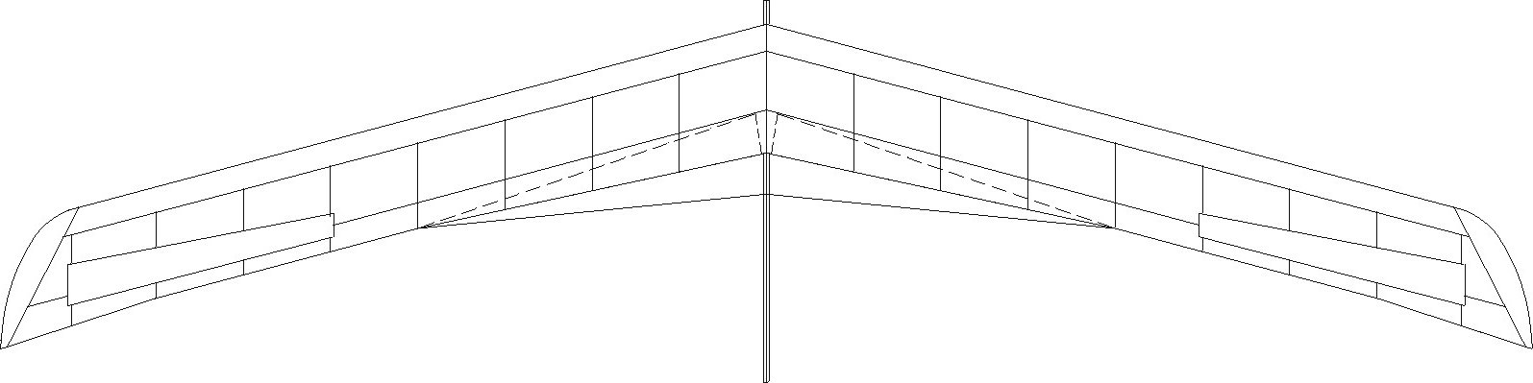
Sail edge
A
B

Tail tube
Keel end

Glider | A mm | B mm
GB | 750 | 770
XTC-160 | 555 | 580
XTC-135 | 535 | 555
A or B
Rope
The glider should be put at horizontal position (keel up). Attention on windy conditions in open fields.
Be sure that your rope is just touching the end of sail. The rope should not be very thick (1-3 mm) and should be well tensioned to avoid slack but take care not to exaggerate and bend the spar.
Rope

